TABLE OF CONTENTS
- Table of contents ………………………………………………………..1
- Student notes………………………………………………………………2
- Quizzes ……………………………………………………………………….3-4
  - Assessment 2…………………………………………………..3
  - Assessments 1…………………………………………………4
- Handouts…………………………………………………………………….5
- Design notes……………………………………………………………….6
- Grade sheet………………………………………………………………..7
- Conclusion………………………………………………………………….8

STUDENTS NOTES
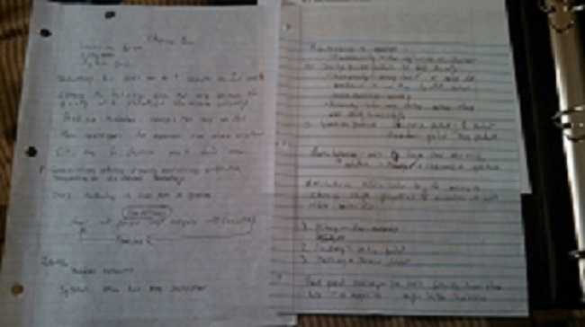

QUIZZES/EXAMS
Assement 2

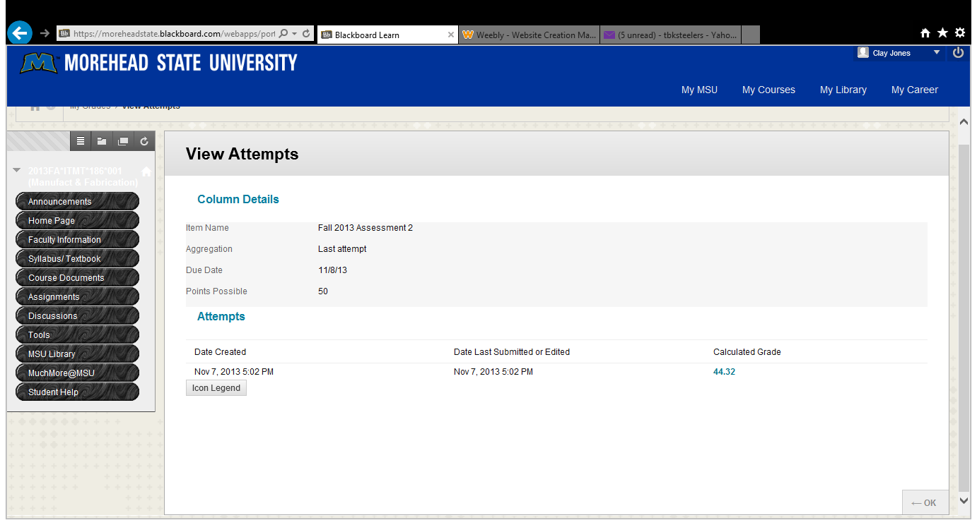

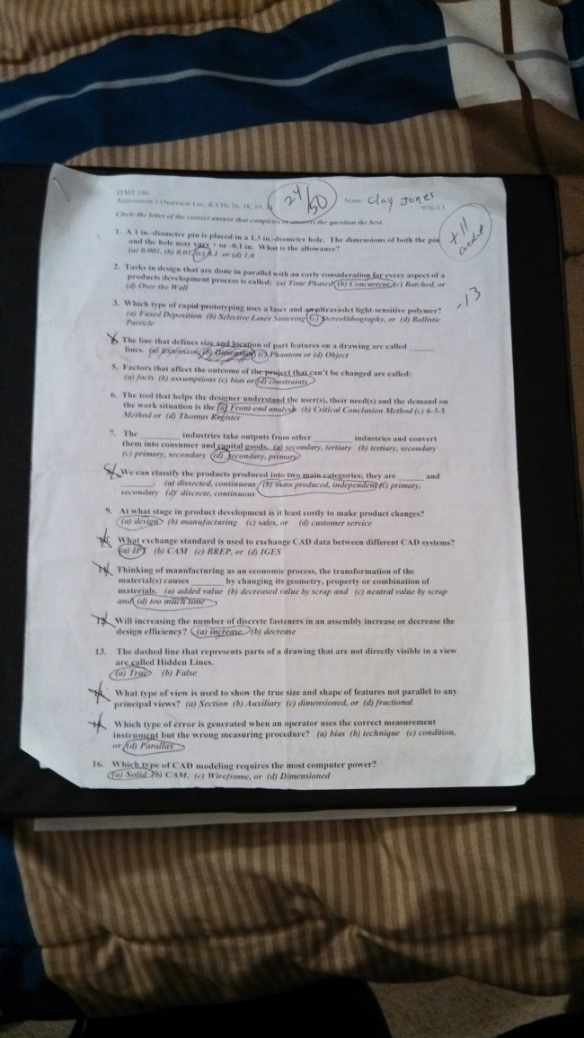
Assessments 1

HANDOUTS
C:\Users\clayjones\Desktop\PK-PEN_ins.pdf
C:\Users\clayjones\Pictures\CNC_Project2.pdf
C:\Users\clayjones\Pictures\Design and Process Project-USB drive(1).pdf

DESIGN NOTES
USB DESIGN
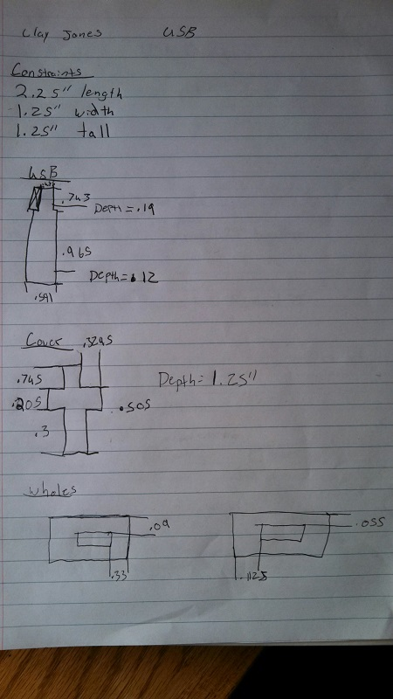
GRADE SHEET
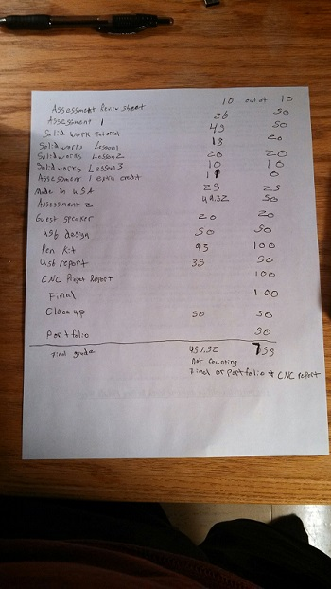
This is without my final, CNC project report, and my portfolio. So hopefully I end up with a high B or an A.

CONCLUSION
I really liked the class and has helped with many manufacturing and computer based software’s. I liked the class because it tested me a lot in creating process of fabrication. I don’t have many improvements for the class except I wanted to make the USB and the CNC but other than I liked the class.

